Dear Professional Colleague,

We hope you, your family and all your near and dear ones are keeping in good health.

The Transparency in Taxation System – Prospective Vision of Our Honourable Prime Minister to Initiate Next Phase of Reforms of The Direct Taxes Which Is Aimed at Easing the Tax Compliance & also Rewarding Honest Taxpayers.

We have organised Webinar for “Transparent Taxation - Honouring the Honest”.

The details of Topics, Date, Time and faculty is as follows
TOPIC | DATE | TIME | FACULTY
HONOURING THE HONEST | 27thAug 2020  Thursday | 6.00 pm to  7.30 pm | Senior Advocate Saurabh Soparkar  (Ahmedabdad) | 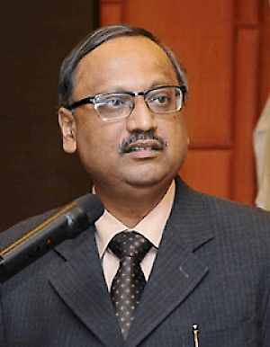

The Fees for Member Rs. 100/- and Nom Member Rs.125/- per Session. Online Registration and payment link

For 27/8/2020
Link Provided Shortly……..

For, Chartered Accountants Association, Ahmedabad  CA. Ketan Mistry CA Mihir Pujara  President Hon. Secretary | For, Study Circle (Direct Tax) Committee of Chartered Accountants Association, Ahmedabad  CA. Palak B Pavagadhi CA. Harshid A Patel  Chairman Convenor

